A short overview of new EpiData Analysis (2018)

EpiData Analysis is used for data management and quantitative statistical data analysis.

Use EpiData analysis when you want to do simple or comprehensive data management and basic descriptive statistical analyses. Extended statistical modelling must be done with other software such as R, Stata etc. Operating systems supported: Linux, Windows and Machintosh.

The final EpiData Analysis Classic developed from 2004-2014 is version 2.2 rel 3 (Build 187) is available from www.epidata.dk. The classic version will not be further updated.

The new EpiData Analysis v1.0 was first released in April 2018 with the following functionality:
- Comprehensive data management, data verification, checks and documentation features. Data may be verified (validate and check data)
- Read & write several data formats (epx/epz, encrypted epx/epz, csv, Stata) and export DDI-v3.1. All character handling is UTF-8 compatible. Results may be saved in text or html format. The previous rec+chk format may be read, but not written.
- Function is validated with several batch tests for datasets up to 125000 observations and 250 variables. But also related datasets and encrypted projects with user logging.
- Analysis commands in v1.0: count, frequencies, means. Following release of v1.0 collapsing of data (aggregate), crosstables, table estimation and graphs will be implemented. See www.epidata.dk for news and updates.

Download and install from www.epidata.dk and follow the instructions when you run the installation file. For windows this is a combined installer for EpiData Manager, EntryClient and Analysis. EpiData Analysis will not interfere with the setup of your computer. EpiData consists of one exe program file and a number of help files in html or pdf format

When you start Analysis you will see this, if you open the help menu. After reading a file (File menu) you can see the datasets with function key F2, variables with F3, history F7, editor F5 and databrowser with F6.
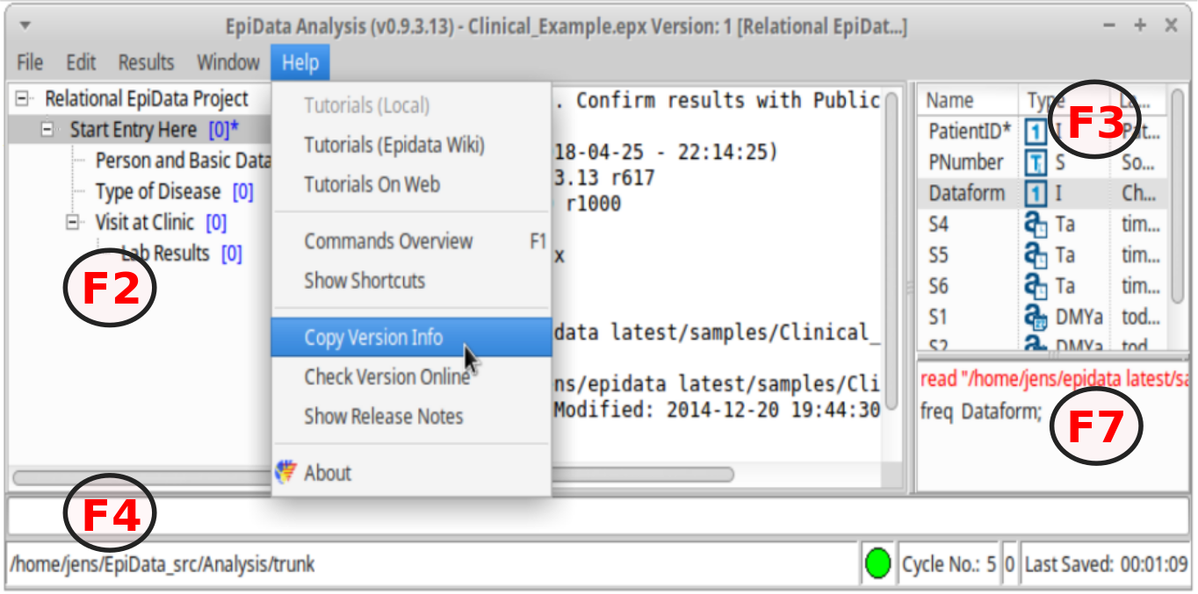
.

License The program as such cannot be sold for money or service value. It is absolutely free. There can be NO charge taken by a web site for downloading of EpiData. Distributed according to a CC license.

Further help All users are encouraged to seek information on the EpiData discussion list and also join that list at: http://lists.umanitoba.ca/mailman/listinfo/epidata-list. By joining the list you will receive information on updates and help us in deciding how to proceed development. When you install the software example files and further documentation is also installed. This is available through the “help menu”

Flowsheet A simplified flowsheet of how EpiData Analysis is working is shown on the next page. Blue parts are optional, black parts are in memory and red parts save permanently to disk. Note that the programme always works with a copy of data. Your data on the disk are not changed unless you as a user instruct the programme to do so. Note also that the commands issued are saved when you exit.

Flowsheet of working with EpiData Analysis

Keep a COPY of data in memory

Read a data file
(epx, csv, dta, rec)
For files with metadata (epx, dta). Read variable + value labels and further project information (epx), including missing value definitions.
Add new variables new var

Change contents of variables
edit
if ... then ...,
select ... do
Change sorting
sort command
Modify data in memory

Save data to disk
Command save

Show results on the Screen

Write results to disk:
save ... !output
”Next” Analysis command
Stop Analysis
quit or exit

All commands are saved in commandlog.pgm

A. Start EpiData from either the programme group where you installed the programme or an icon on Your desktop.

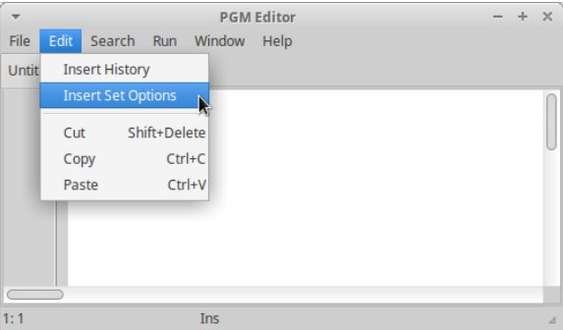
B. First time you run EpiData Analysis You may want to change some defaults or font sizes. Look in the main menu under “Edit” 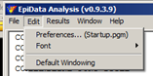.

If you want to change these permanently then start instead the "preferences", which will open the editor. Here you may either add history or insert all possible set options.

C. You may then run (see editor menu) the sets defined or save and restart the software.

2. First trial with programme:

To give you an idea of how the programme works try the following:

Find “Read Data” in the file menu to the left on your screen and point your disk selector to where you installed the EpiData Analysis programme in the subfolder “samples”.

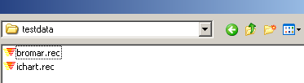
Select “bromar.rec” or bromar.epx
(possibly shown only as “bromar”).
by double clicking and notice the information in the output window, How many records and fields ?

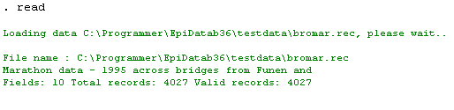
Data
A copy of data is red into memory for a Marathon race.

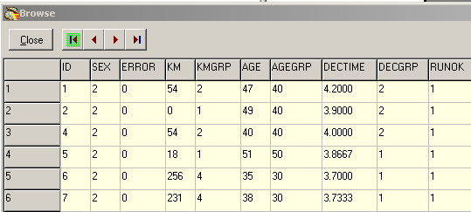
Browse data
Every time you open a data file it is good practice to view the data.

So press the F6 function key and you will see the data in a spreadsheet form

A data browser window is shown. Look at the data. Resize the window to cover right half of the screen and just leave it there.

Showing a table of frequencies
In the command prompt (F4) write "freq" and then in the variables window (F3) doubleclick on one variable and then press the enter key. You will see that the name is copied to the command prompt. If you now press enter, the frequency table will be shown. If you add !r and !ci to the command, then percentages and confidence intervals are shown to the right of the numbers of observations.

Select sex and agegrp variables in the dialog which is shown and press ”run”, after which you will see these tables:
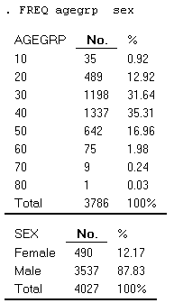

Showing means of age by time
Write instead in the command prompt (F4) now "Means", choose the variable age (F3) ” hit enter. After seing the result press again F4 and "up arrow", which will show the command again. Add to the end of this !t !by:= sex

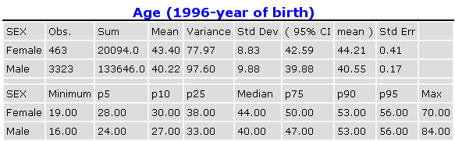
Are males or females on average the youngest ?

3. Which elements are on the screen ?
You have now acquainted your self with the programme and working with the process toolbar. On this page you see a complete picture.

To get acquainted with the windows try the following:
1. Switch the extra windows on the right on and off a few times: Press keys: F2, F3 or F7
2. Resize the program by dragging in sides or the separator between output window (viewer) and right side parts.
3. Save current position in window menu. ”Save Window Position”
4. Try to change folder by clicking on the lower left side of the statusbar.
5. Try the editor. From within you can run commands or save pgm files for future use.
6. Try the help menu. If you are connected to internet you can activate ”Check Version” part which will compare your version with the most updated on on www.epidata.dk

Further introduction
Try the programme as it is and experience how you can soon get into more commands or features. If you press F1 an overview of help files is shown and if you press find (Ctrl+F) you can soon see how to get further explanations.

Support

Sources for support:
1..Read the help files (press F1)
2. nfortunately we do not have resources for support of questions in general refer these to the EpiData-list at http://lists.umanitoba.ca/mailman/listinfo/epidata-list

If you find errors or bugs when using the program or have suggestions for improval please discuss with the EpiData-list available at http://lists.umanitoba.ca/mailman/listinfo/epidata-list

Suggested citation of EpiData Analysis program:

(see later)

Funding and acknowledgements.
An updated list of attained funding is available at Http://www.epidata.dk/funding.htm. Further credits and acknowledgements at: Http://www.epidata.dk/credit.htm . International translations made to several languages, see Http://www.epidata.dk For donations to further development see help file or send an e-mail to info@epidata.dk. Isolated parts of source code based on freeware and shareware components. Please consult credit pages.

Disclaimer
The EpiData Analysis software program was developed and tested to ensure fail-safe analysis and documentation of data. We made every possible effort in producing a fail-safe program, but cannot in any circumstance be held responsible for errors, loss of data, work time or other losses incurred by or in relation to the program.

